UNIT – II
- Discuss in detail any one of the non procedural query language. (OR) Explain about Tuple Relational Calculus ( MAY 2012) (MAY 2009 )
Relational Calculus:
* Lets users describe what they want, rather than how to compute it. (Non-operational, declarative.)

Tuple Relational Calculus
The tuple calculus is a calculus that was introduced by Edgar F. Codd as part of the relational model in order to give a declarative database query language for this data model.
It formed the inspiration for the database query languages QUEL and SQL of which the latter, although far less faithful to the original relational model and calculus, is now used in almost all relational database management systems as the ad-hoc query language.
Along with the tuple calculus Codd also introduced the domain calculus which is closer to first-order logic and showed that these two calculi (and the relational algebra) are equivalent in expressive power. Subsequently query languages for the relational model were called relationally complete if they could express at least all these queries.
  - A nonprocedural query language, where each query is of the form
      - {t | P (t) }
  - It is the set of all tuples t such that predicate P is true for t
  - t is a tuple variable, t[A] denotes the value of tuple t on attribute A
  - t ∈ r denotes that tuple t is in relation r
  - P is a formula similar to that of the predicate calculus
Predicate Calculus Formula
1. Set of attributes and constants
2. Set of comparison operators: (e.g., <, ≤, =, ≠, >, ≥)
3. Set of connectives: and (∧), or (v)‚ not (¬)
4. Implication (⇒): x ⇒ y, if x if true, then y is true
x ⇒ y ≡ ¬x v y
5. Set of quantifiers:
  - ∃ t ∈ r (Q(t)) ≡ ”there exists” a tuple in t in relation r
such that predicate Q(t) is true
  - ∀t ∈ r (Q(t)) ≡ Q is true “for all” tuples t in relation r
Safety of Expressions
- It is possible to write tuple calculus expressions that generate infinite relations.
- For example, {t | ¬ t ∈ r} results in an infinite relation if the domain of any attribute of relation r is infinite
- To guard against the problem, we restrict the set of allowable expressions to safe expressions.
- An expression {t | P(t)} in the tuple relational calculus is safe if every component of t appears in one of the relations, tuples, or constants that appear in P
Banking Example
- branch (branch-name, branch-city, assets)
- customer (customer-name, customer-street, customer-city)
- account (account-number, branch-name, balance)
- loan (loan-number, branch-name, amount)
- depositor (customer-name, account-number)
- borrower (customer-name, loan-number)
Example Queries
- Find the loan-number, branch-name, and amount for loans of over $1200
{t | t ∈ loan ∧ t [amount] > 1200}
- Find the loan number for each loan of an amount greater than $1200
{t | ∃ s ∈ loan (t[loan-number] = s[loan-number]
∧ s [amount] > 1200}
- Find the names of all customers having a loan, an account, or both at the bank
{t | ∃s ∈ borrower(t[customer-name] = s[customer-name])
∨ ∃u ∈ depositor(t[customer-name] = u[customer-name])
- Find the names of all customers who have a loan and an account at the bank
{t | ∃s ∈ borrower(t[customer-name] = s[customer-name])
∧ ∃u ∈ depositor(t[customer-name] = u[customer-name
- Find the names of all customers having a loan at the Perryridge branch
{t | ∃s ∈ borrower(t[customer-name] = s[customer-name]
∧ ∃u ∈ loan(u[branch-name] = “Perryridge”
∧ u[loan-number] = s[loan-number]))}
- Find the names of all customers who have a loan at the Perryridge branch, but no account at any branch of the bank
{t | ∃s ∈ borrower(t[customer-name] = s[customer-name]
∧ ∃u ∈ loan(u[branch-name] = “Perryridge”
∧ u[loan-number] = s[loan-number]))
∧ not ∃v ∈ depositor (v[customer-name] = t[customer-name]) }

- Find the names of all customers having a loan from the Perryridge branch, and the cities they live in
{t | ∃s ∈ loan(s[branch-name] = “Perryridge”
∧ ∃u ∈ borrower (u[loan-number] = s[loan-number]
∧ t [customer-name] = u[customer-name])
∧ ∃ v ∈ customer (u[customer-name] = v[customer-name]
∧ t[customer-city] = v[customer-city])))}

- Find the names of all customers who have an account at all branches located in Brooklyn:
{t | ∃ c ∈ customer (t[customer.name] = c[customer-name]) ∧
∀ s ∈ branch(s[branch-city] = “Brooklyn” ⇒
∃ u ∈ account ( s[branch-name] = u[branch-name]
∧ ∃ s ∈ depositor ( t[customer-name] = s[customer-name]
∧ s[account-number] = u[account-number] )) )}

Domain Relational Calculus

In computer science, domain relational calculus (DRC) is a calculus that was introduced by Michel Lacroix and Alain Pirotte as a declarative database query language for the relational data model.
- A nonprocedural query language equivalent in power to the tuple relational calculus
- Each query is an expression of the form:
{ < x₁, x₂, …, x_{n} > | P(x₁, x₂, …, x_{n})}
x₁, x₂, …, x_{n} represent domain variables
- P represents a formula similar to that of the predicate calculus
This language uses the same operators as tuple calculus; Logicial operators ∧ (and), ∨ (or) and ¬ (not). The existential quantifier (∃) and the universal quantifier (∀) can be used to bind the variables.
Safety of Expressions
{ < x₁, x₂, …, x_{n} > | P(x₁, x₂, …, x_{n})} is safe if all of the following hold:
- All values that appear in tuples of the expression are values from dom(P) (that is, the values appear either in P or in a tuple of a relation mentioned in P).
- For every “there exists” subformula of the form ∃ x (P₁(x)), the subformula is true if an only if P₁(x) is true for all values x from dom(P₁).
- For every “for all” subformula of the form ∀_{x} (P₁ (x)), the subformula is true if and only if P₁(x) is true for all values x from dom (P₁).
Example Queries
- Find the branch-name, loan-number, and amount for loans of over $1200
{< l, b, a > | < l, b, a > ∈ loan ∧ a > 1200}
- Find the names of all customers who have a loan of over $1200
{< c > | ∃ l, b, a (< c, l > ∈ borrower ∧ < l, b, a > ∈ loan ∧ a > 1200)}
- Find the names of all customers who have a loan from the Perryridge branch and the loan amount:
{< c, a > | ∃ l (< c, l > ∈ borrower ∧ ∃b(< l, b, a > ∈ loan ∧
b = “Perryridge”))}
or {< c, a > | ∃ l (< c, l > ∈ borrower ∧ < l, “Perryridge”, a > ∈ loan)}
- Find the names of all customers having a loan, an account, or both at the Perryridge branch:

{< c > | ∃ l ({< c, l > ∈ borrower
∧ ∃ b,a(< l, b, a > ∈ loan ∧ b = “Perryridge”))
∨ ∃ a(< c, a > ∈ depositor
∧ ∃ b,n(< a, b, n > ∈ account ∧ b = “Perryridge”))}

2. Write short notes on
a) set operations
b) aggregate function.

A).Set Operations
- Set operators combine the results of two or more component queries into one result. Queries containing set operators are called compound queries.
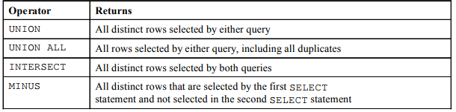
- The SQL operations union, intersect, and except operate on relations and correspond to the relational-algebra operations ∪, ∩, and −. Like union, intersection, and set difference in relational algebra, the relations participating in the operations must be compatible; that is, they must have the same set of attributes.

- We shall now construct queries involving the union, intersect, and except operations of two sets: the set of all customers who have an account at the bank, which can be derived by
select customer-name
from depositor
- and the set of customers who have a loan at the bank, which can be derived by
select customer-name
from borrower

- the depositer(d) table is shown below
CUSTOMER_Name ACCOUNT_NUMBER
-------------------------- ------------------------------
Hayes 102
Johnson 101
Johnson 201
Jones 217
Lindsay 222
Smith 215
Turner 305
- The borrower(b) table is shown below
CUSTOMER_Name LOAN_NUMBER
--------------------------- --------------------------
Adams 16
Curry 93
Hayes 15
Jackson 14
Jones 17
Smith 11
Smith 23
Williams 17
The Union Operation
- To find all customers having a loan, an account, or both at the bank, we write

- (select customer-name from depositor) union (select customer-name from borrower)
CUSTOMER_N
----------------------
Adams
Curry
Hayes
Jackson
Johnson
Jones
Jones
Lindsay
Smith
Smith
Turner
Williams
- The union operation automatically eliminates duplicates, unlike the select clause. Thus, in the preceding query, if a customer—say, Jones—has several accounts or loans (or both) at the bank, then Jones will appear only once in the result. If we want to retain all duplicates, we must write union all in place of union:

- (select customer-name from depositor)union all (select customer-name from borrower)

CUSTOMER_Name
----------------------------
Hayes
Johnson
Johnson
Jones
Lindsay
Smith
Turner
Adams
Curry
Hayes
Jackson

CUSTOMER_Name
---------------------------
Jones
Smith
Smith
Williams
- The number of duplicate tuples in the result is equal to the total number of duplicates that appear in both d and b. Thus, if Jones has three accounts and two loans at the bank, then there will be five tuples with the name Jones in the result.

The Intersect Operation
- To find all customers who have both a loan and an account at the bank, we write

- (select distinct customer-name from depositor)intersect (select distinct customer-name from borrower)

CUSTOMER_Name
---------------------------
Hayes
Smith
- The intersect operation automatically eliminates duplicates. Thus, in the preceding query, if a customer_say, Jones_has several accounts and loans at the bank, then Jones will appear only once in the result.

The Except Operation
- To find all customers who have an account but no loan at the bank, we write

- (select distinct customer-name from depositor)except (select customer-name from borrower)
- The except operation automatically eliminates duplicates. Thus, in the preceding query, a tuple with customer name Jones will appear (exactly once) in the result only if Jones has an account at the bank, but has no loan at the bank.
- (select customer-name from depositor)except all (select customer-name from borrower)
- The number of duplicate copies of a tuple in the result is equal to the number of duplicate copies of the tuple in d minus the number of duplicate copies of the tuple in b, provided that the difference is positive.
- Thus, if Jones has three accounts and one loan at the bank, then there will be two tuples with the name Jones in the result. If, instead, this customer has two accounts and three loans at the bank, there will beno tuple with the name Jones in the result.

b) AGGREGATE FUNCTIONS
- Aggregate functions are functions that take a collection (a set or multiset) of values as input and return a single value. SQL offers five built-in aggregate functions:
• Average: avg
• Minimum: min
• Maximum: max
• Total: sum
• Count: count

Average: avg
- The input to sum and avg must be a collection of numbers, but the other operators can operate on collections of nonnumeric data types, such as strings, as well. As an illustration, consider the query “Find the average account balance. We write this query as follows:
Table account

ACCOUNT_NUMBER BRANCH_NAME BALANCE
---------------------------- ----------------------- ---------------
101 Downtown 500
102 Perryridge 400
201 Brighton 900
215 Mianus 700
217 Brighton 700
222 Redwood 700
305 Round Hill 350

- select avg (balance) from account;
AVG(BALANCE)
---------------------
607.142857
- The result of this query is a relation with a single attribute, containing a single tuple with a numerical value corresponding to the average balance at the Perryridge branch.
Count: count
- We use the aggregate function count frequently to count the number of tuples in a relation. The notation for this function in SQL is count (*). Thus, to find the number of tuples in the customer relation, we write

- select count (*) from account;
COUNT(*)
---------------
7
Minimum: min
- we can find out minimum value using the MIN group function.
- SELECT MIN(balance) from account;
MIN(BALANCE)
--------------------
350
Maximum: max
- we can find out maximum value using the MAX group function.

- SELECT MAX(balance) from account;

MAX(BALANCE)
----------------------
900
Total: sum
- we can find out Total value using the SUM group function.
- SELECT SUM (balance) from account;
SUM (BALANCE)
--------------------
4250
3. HOW JOIN RELATIONS ARE HANDLED IN SQL?
SQL JOINS are used in a SQL query to retrieve data from multiple tables. A SQL JOIN is performed whenever two or more tables are joined in a SQL statement.
There are 4 different types of SQL joins:
- SQL INNER JOIN (or sometimes called simple join)
- SQL LEFT OUTER JOIN (or sometimes called LEFT JOIN)
- SQL RIGHT OUTER JOIN (or sometimes called RIGHT JOIN)
- SQL FULL OUTER JOIN (or sometimes called FULL JOIN)

SQL INNER JOIN (simple join)
- Chances are, you've already written a SQL statement that uses an SQL INNER JOIN. It is the most common type of SQL join. SQL INNER JOINS return all rows from multiple tables where the join condition is met.

SQL INNER JOIN Syntax
The syntax for the SQL INNER JOIN is:
- SELECT columns FROM table1 INNER JOIN table2
ON table1.column = table2.column;
In this diagram, the SQL INNER JOIN returns the shaded area:
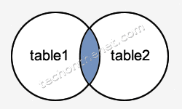
The SQL INNER JOIN would return the records where table1 and table2 intersect.

SQL INNER JOIN Examples
Here is an example of a SQL INNER JOIN:
- SELECT suppliers.supplier_id, suppliers.supplier_name, orders.order_date
FROM suppliers INNER JOIN orders ON suppliers.supplier_id = orders.supplier_id;
- This SQL INNER JOIN example would return all rows from the suppliers and orders tables where there is a matching supplier_id value in both the suppliers and orders tables.
- We have a table called suppliers with two fields (supplier_id and supplier_name). It contains the following data:

supplier_id | supplier_name
10000 | IBM
10001 | Hewlett Packard
10002 | Microsoft
10003 | NVIDIA
- We have another table called orders with three fields (order_id, supplier_id, and order_date). It contains the following data:
order_id | supplier_id | order_date
500125 | 10000 | 2003/05/12
500126 | 10001 | 2003/05/13
500127 | 10004 | 2003/05/14
- If we run the SQL statement (that contains an INNER JOIN) below:
- SELECT suppliers.supplier_id, suppliers.supplier_name, orders.order_date
FROM suppliers INNER JOIN orders ON suppliers.supplier_id = orders.supplier_id;

Our result set would look like this:
supplier_id | name | order_date
10000 | IBM | 2003/05/12
10001 | Hewlett Packard | 2003/05/13
- The rows for Microsoft and NVIDIA from the supplier table would be omitted, since the supplier_id's 10002 and 10003 do not exist in both tables. The row for 500127 (order_id) from the orders table would be omitted, since the supplier_id 10004 does not exist in the suppliers table.

SQL LEFT OUTER JOIN
- Another type of join is called a LEFT OUTER JOIN. This type of join returns all rows from the LEFT-hand table specified in the ON condition and only those rows from the other table where the joined fields are equal (join condition is met).

SQL LEFT OUTER JOIN Syntax
The syntax for the SQL LEFT OUTER JOIN is:
- SELECT columns FROM table1 LEFT [OUTER] JOIN table2
ON table1.column = table2.column;.
In this diagram, the SQL LEFT OUTER JOIN returns the shaded area:
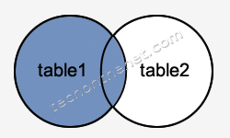
- The SQL LEFT OUTER JOIN would return the all records from table1 and only those records from table2 that intersect with table1.

SQL LEFT OUTER JOIN Examples
Here is an example of a SQL LEFT OUTER JOIN:
- SELECT suppliers.supplier_id, suppliers.supplier_name, orders.order_date
FROM suppliers LEFT OUTER JOIN orders ON suppliers.supplier_id = orders.supplier_id;
- This LEFT OUTER JOIN example would return all rows from the suppliers table and only those rows from the orders table where the joined fields are equal.
- If a supplier_id value in the suppliers table does not exist in the orders table, all fields in the orders table will display as <null> in the result set.
- Let's look at some data to explain how LEFT OUTER JOINS work:
- We have a table called suppliers with two fields (supplier_id and name). It contains the following data:
supplier_id | supplier_name
10000 | IBM
10001 | Hewlett Packard
10002 | Microsoft
10003 | NVIDIA
- We have a second table called orders with three fields (order_id, supplier_id, and order_date). It contains the following data:
order_id | supplier_id | order_date
500125 | 10000 | 2003/05/12
500126 | 10001 | 2003/05/13
- If we run the SQL statement (that contains a LEFT OUTER JOIN) below:
- SELECT suppliers.supplier_id, suppliers.supplier_name, orders.order_date
FROM suppliers LEFT OUTER JOIN orders ON suppliers.supplier_id = orders.supplier_id;
- Our result set would look like this:
supplier_id | supplier_name | order_date
10000 | IBM | 2003/05/12
10001 | Hewlett Packard | 2003/05/13
10002 | Microsoft | <null>
10003 | NVIDIA | <null>
- The rows for Microsoft and NVIDIA would be included because a LEFT OUTER JOIN was used. However, you will notice that the order_date field for those records contains a <null> value.

SQL RIGHT OUTER JOIN
- Another type of join is called a SQL RIGHT OUTER JOIN. This type of join returns all rows from the RIGHT-hand table specified in the ON condition and only those rows from the other table where the joined fields are equal (join condition is met).

SQL RIGHT OUTER JOIN Syntax
- The syntax for the SQL RIGHT OUTER JOIN is:
- SELECT columns FROM table1RIGHT [OUTER] JOIN table2 ON table1.column = table2.column;
- In this diagram, the SQL RIGHT OUTER JOIN returns the shaded area:
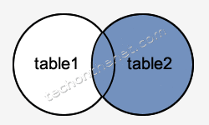
- The SQL RIGHT OUTER JOIN would return the all records from table2 and only those records from table1 that intersect with table2.

SQL RIGHT OUTER JOIN Examples
Here is an example of a SQL RIGHT OUTER JOIN:
- SELECT orders.order_id, orders.order_date, suppliers.supplier_name FROM suppliers RIGHT OUTER JOIN orders ON suppliers.supplier_id = orders.supplier_id;
- This RIGHT OUTER JOIN example would return all rows from the orders table and only those rows from the suppliers table where the joined fields are equal.
- If a supplier_id value in the orders table does not exist in the suppliers table, all fields in the suppliers table will display as <null> in the result set.
- Let's look at some data to explain how RIGHT OUTER JOINS work:
- We have a table called suppliers with two fields (supplier_id and name). It contains the following data:
supplier_id | supplier_name
10000 | Apple
10001 | Google
- We have a second table called orders with three fields (order_id, supplier_id, and order_date). It contains the following data:
order_id | supplier_id | order_date
500125 | 10000 | 2013/08/12
500126 | 10001 | 2013/08/13
500127 | 10002 | 2013/08/14
- If we run the SQL statement (that contains a RIGHT OUTER JOIN) below:
- SELECT orders.order_id, orders.order_date, suppliers.supplier_name
FROM suppliers
RIGHT OUTER JOIN orders
ON suppliers.supplier_id = orders.supplier_id;
- Our result set would look like this:
order_id | order_date | supplier_name
500125 | 2013/08/12 | Apple
500126 | 2013/08/13 | Google
500127 | 2013/08/14 | <null>
- The row for 500127 (order_id) would be included because a RIGHT OUTER JOIN was used. However, you will notice that the supplier_name field for that record contains a <null> value.

SQL FULL OUTER JOIN
- Another type of join is called a SQL FULL OUTER JOIN. This type of join returns all rows from the LEFT-hand table and RIGHT-hand table with nulls in place where the join condition is not met.

SQL FULL OUTER JOIN Syntax
- The syntax for the SQL FULL OUTER JOIN is:
SELECT columns
FROM table1
FULL [OUTER] JOIN table2
ON table1.column = table2.column;
In this diagram, the SQL FULL OUTER JOIN returns the shaded area:
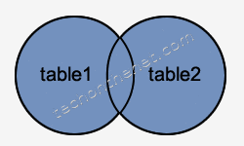
- The SQL FULL OUTER JOIN would return the all records from both table1 and table2.

SQL FULL OUTER JOIN Examples
Here is an example of a SQL FULL OUTER JOIN:
SELECT suppliers.supplier_id, suppliers.supplier_name, orders.order_date
FROM suppliers FULL OUTER JOIN orders ON suppliers.supplier_id = orders.supplier_id;
- This FULL OUTER JOIN example would return all rows from the suppliers table and all rows from the orders table and whenever the join condition is not met, <nulls> would be extended to those fields in the result set.
- If a supplier_id value in the suppliers table does not exist in the orders table, all fields in the orders table will display as <null> in the result set. If a supplier_id value in the orders table does not exist in the suppliers table, all fields in the suppliers table will display as <null> in the result set.
- Let's look at some data to explain how FULL OUTER JOINS work:
- We have a table called suppliers with two fields (supplier_id and name). It contains the following data:
supplier_id | supplier_name
10000 | IBM
10001 | Hewlett Packard
10002 | Microsoft
10003 | NVIDIA
- We have a second table called orders with three fields (order_id, supplier_id, and order_date). It contains the following data:
order_id | supplier_id | order_date
500125 | 10000 | 2013/08/12
500126 | 10001 | 2013/08/13
500127 | 10004 | 2013/08/14
- If we run the SQL statement (that contains a FULL OUTER JOIN) below:
SELECT suppliers.supplier_id, suppliers.supplier_name, orders.order_date
FROM suppliers FULL OUTER JOIN orders ON suppliers.supplier_id = orders.supplier_id;
- Our result set would look like this:
supplier_id | supplier_name | order_date
10000 | IBM | 2013/08/12
10001 | Hewlett Packard | 2013/08/13
10002 | Microsoft | <null>
10003 | NVIDIA | <null>
<null> | <null> | 2013/08/14
- The rows for Microsoft and NVIDIA would be included because a FULL OUTER JOIN was used. However, you will notice that the order_date field for those records contains a <null> value.
- The row for supplier_id 10004 would be also included because a FULL OUTER JOIN was used. However, you will notice that the supplier_id and supplier_name field for those records contain a <null> value.

4. EXPLAIN HOW TO MODIFY A DATABASE WITH EXAMPLE ( MAY 2012)
Deletion:
- A delete request is expressed in much the same way as a query. We can delete only whole tuples; we cannot delete values on only particular attributes. SQL expresses a deletion by
delete from r where P
- where P represents a predicate and r represents a relation. The delete statement first finds all tuples t in r for which P(t) is true, and then deletes them from r.
- The where clause can be omitted, in which case all tuples in r are deleted.

- Note that a delete command operates on only one relation. If we want to delete tuples from several relations, we must use one delete command for each relation.

Delete all account tuples in the Perryridge branch.

delete from account where branch-name = ’Perryridge’

Delete all loans with loan amounts between $1300 and $1500.

delete from loan where amount between 1300 and 1500

Delete all account tuples at every branch located in Needham.

- delete from account where branch-name in (select branch-namefrom branch where branch-city = ’Needham’)
- This delete request first finds all branches in Needham, and then deletes all account tuples pertaining to those branches.

Insertion

- To insert data into a relation, we either specify a tuple to be inserted or write a query whose result is a set of tuples to be inserted.
- Obviously, the attribute values for inserted tuples must be members of the attribute’s domain. Similarly, tuples inserted must be of the correct arity.
- The simplest insert statement is a request to insert one tuple.
- Suppose that we wish to insert the fact that there is an account A-9732 at the Perryridge branch and that is has a balance of $1200.We write
- insert into account values (’A-9732’, ’Perryridge’, 1200)

- In this example, the values are specified in the order in which the corresponding attributes are listed in the relation schema. For the benefit of users who may not remember the order of the attributes, SQL allows the attributes to be specified as part of the insert statement.

- For example, the following SQL insert statements are identical in function to the preceding one:

- insert into account (account-number, branch-name, balance)values (’A-9732’, ’Perryridge’, 1200)
- insert into account (branch-name, account-number, balance)values (’Perryridge’, ’A-9732’, 1200)
- More generally, we might want to insert tuples on the basis of the result of a query. Suppose that we want to present a new $200 savings account as a gift to all loan customers of the Perryridge branch, for each loan they have. Let the loan number serve as the account number for the savings account. We write
- insert into account select loan-number, branch-name, 200 from loan where branch-name = ’Perryridge’

Updates

- The update statement can be used. As we could for insert and delete, we can choose the tuples to be updated by using a query.
- Suppose that annual interest payments are being made, and all balances are to be increased by 5 percent. We write
  - update account set balance = balance * 1.05
- The preceding update statement is applied once to each of the tuples in account relation. If interest is to be paid only to accounts with a balance of $1000 or more, we can write
  - update account set balance = balance * 1.05 where balance >= 1000
Transactions
- A transaction consists of a sequence of query and/or update statements. The SQL standard specifies that a transaction begins implicitly when an SQL statement is executed.
- One of the following SQL statements must end the transaction:

- Commit work commits the current transaction; that is, it makes the updates performed by the transaction become permanent in the database. After the transaction is committed, a new transaction is automatically started.
- Rollback work causes the current transaction to be rolled back; that is, it undoes all the updates performed by the SQL statements in the transaction. Thus, the database state is restored to what it was before the first statement of the transaction was executed.

5. EXPLAIN THE CONCEPT OF REPRESENTING QUERIES BY EXAMPLE.
Query by Example (QBE) is a database query language for relational databases. It was devised by Moshé M. Zloof at IBM Research during the mid 1970s, in parallel to the development of SQL. It is the first graphical query language, using visual tables where the user would enter commands, example elements and conditions. Many graphical front-ends for databases use the ideas from QBE today.
QBE is based on the notion of Domain relational calculus.
Query by Example (QBE) is a powerful search tool that allows anyone to search a system for document(s) by entering an element such as a text string or document name, quickly searching through documents to match your entered criteria.
It’s commonly believed that QBE is far easier to learn than other, more formal query languages, (i.e. SQL) while still providing people with the opportunity to perform powerful searches.
Searching for documents based on matching text is easy with QBE; the user simply enters (or copy and paste) the target text into the search form field. When the user clicks search (or hits enter) the input is passed to the QBE parser for processing.
The query is created and then the search begins, using key words from the input the user provided. It auto-eliminates mundane words such as and, is, or, the, etc… to make the search more efficient and not to barrage the user with results. However, when compared with a formal query, the results in the QBE system will be more variable.
The user can also search for similar documents based on the text of a full document that he or she may have. This is accomplished by the user’s submission of documents (or numerous documents) to the QBE results template. The analysis of these document(s) the user has inputted via the QBE parser will generate the required query and submits it to the search engine, that will obviously then search for relevant and similar material for the specified list.
QBE Skeleton Tables for the Bank Example
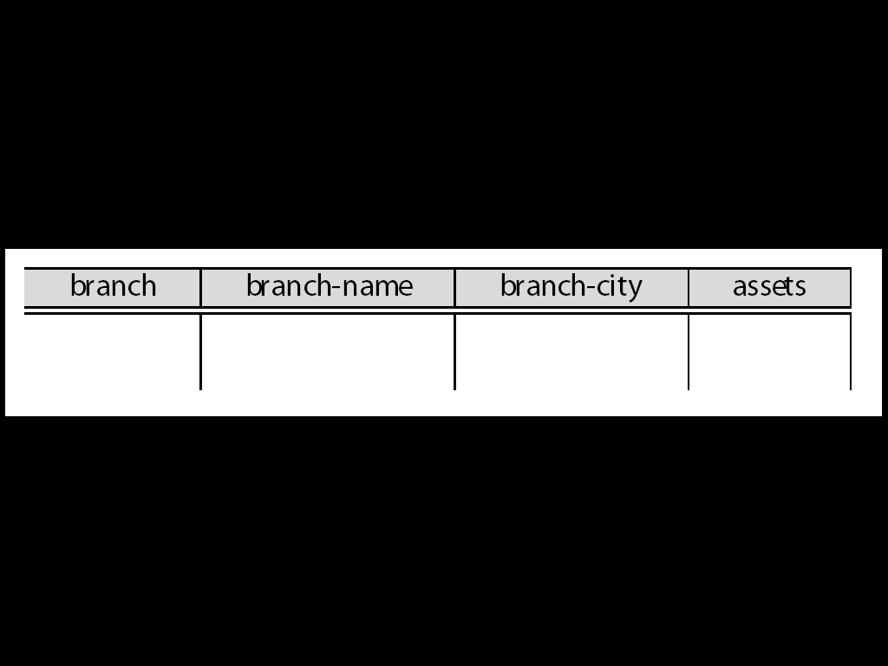
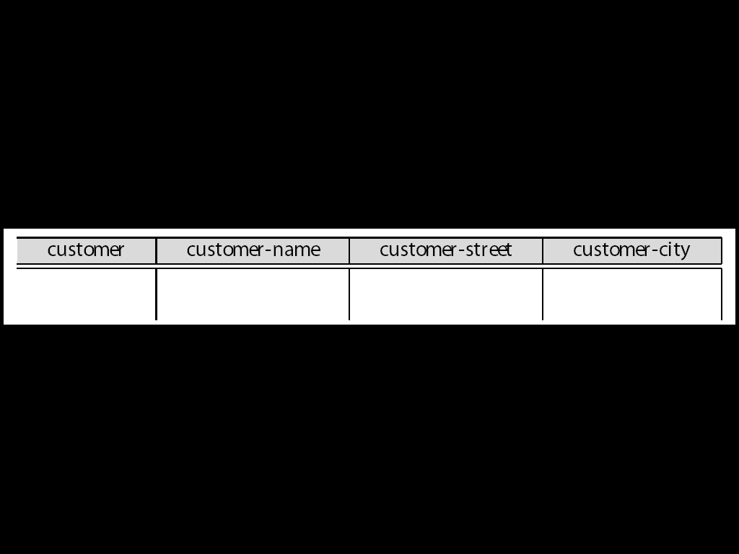
Queries on One Relation
- Find all loan numbers at the Perryridge branch.
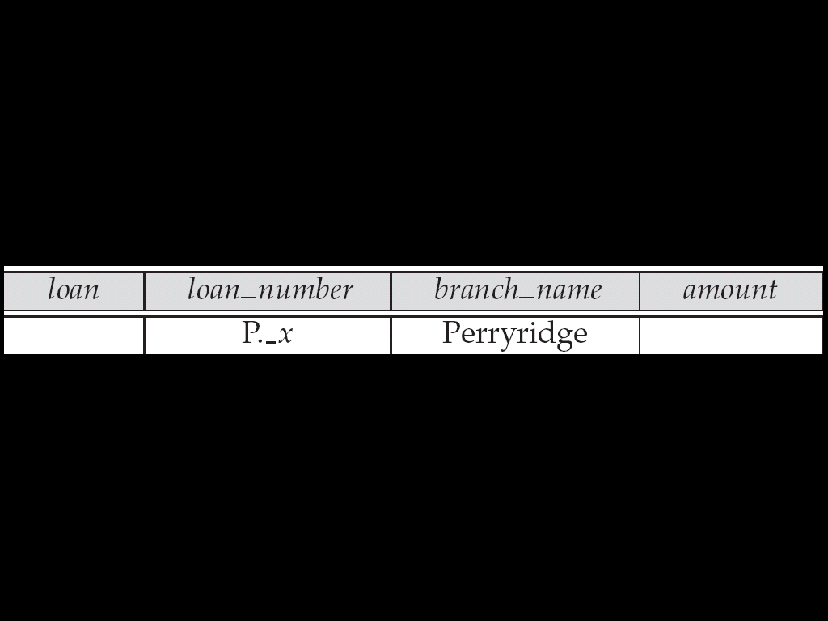
- _x is a variable (optional; can be omitted in above query)
- P. means print (display)
- duplicates are removed by default
- To retain duplicates use P.ALL
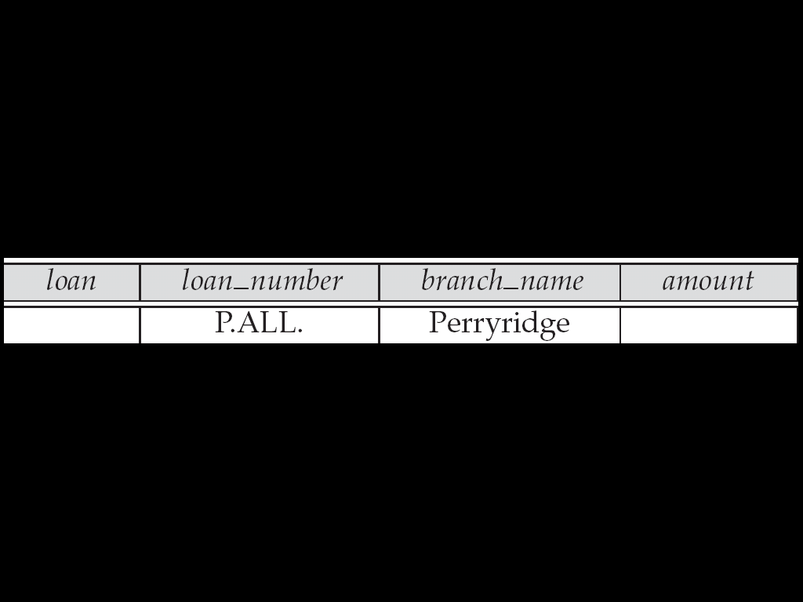

Display full details of all loans
- Method 1:
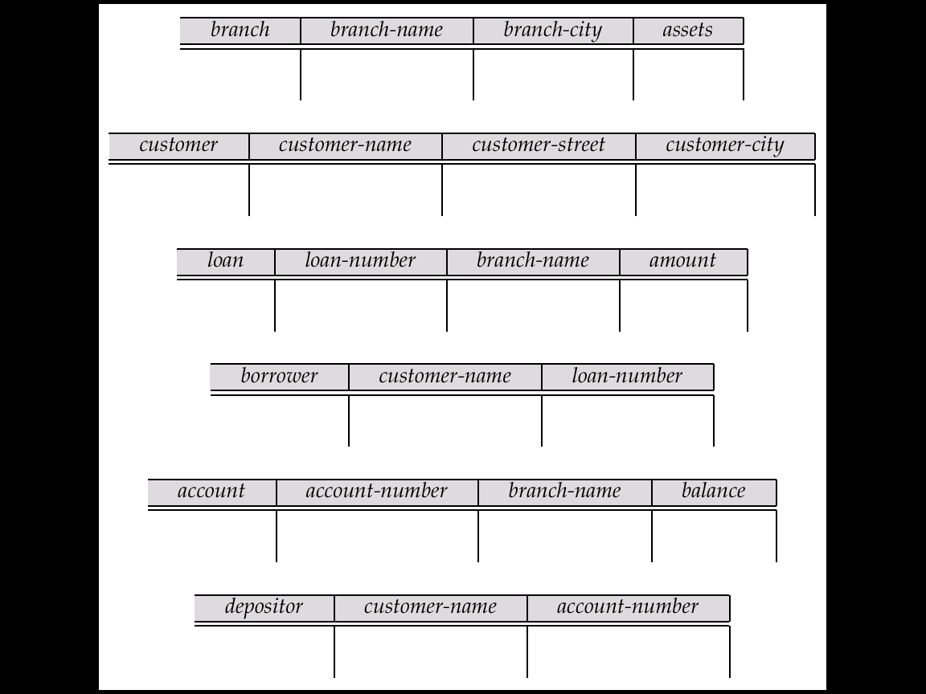
- Method 2: Shorthand notation
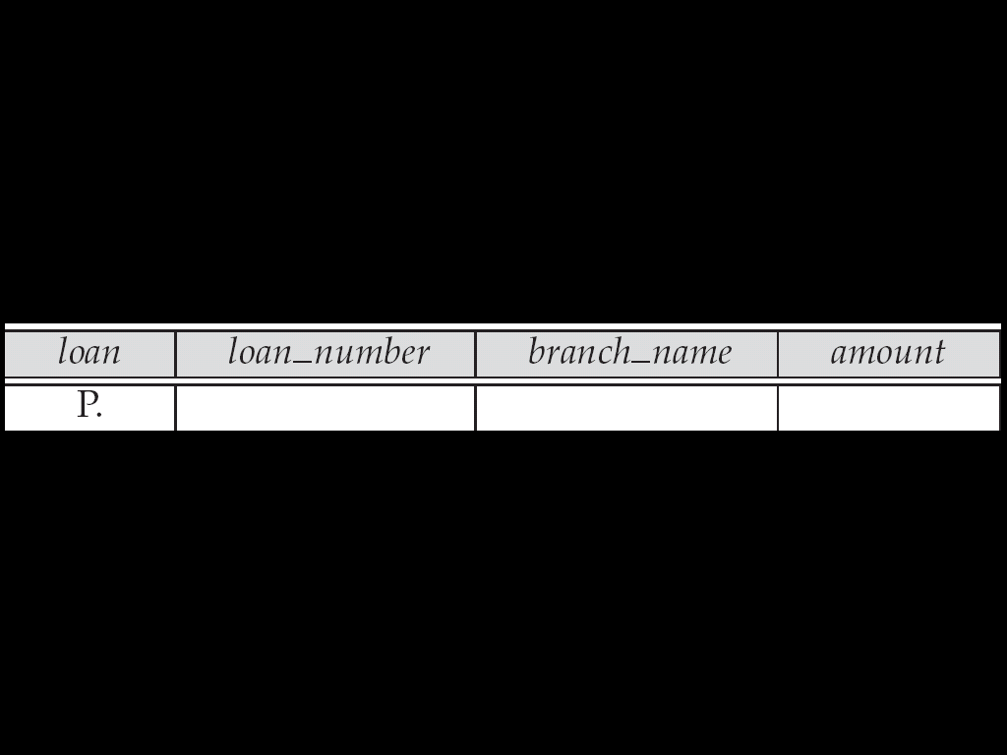
Queries on Several Relations
- Find the names of all customers who have both an account and a loan at the bank.
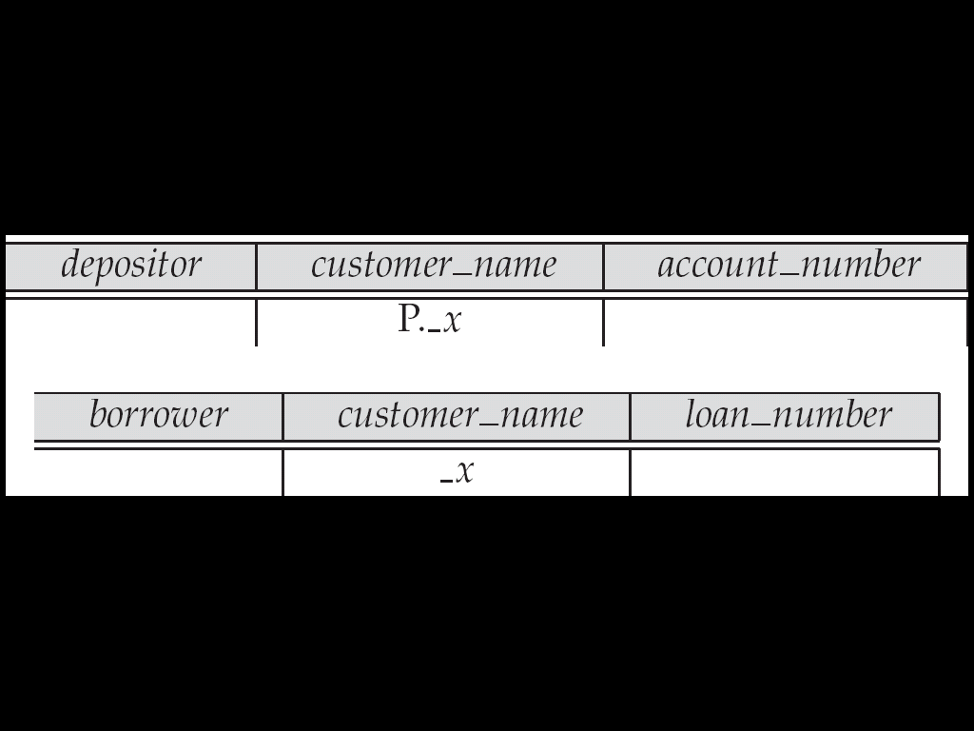
Negation in QBE
- Find the names of all customers who have an account at the bank, but do not have a loan from the bank.
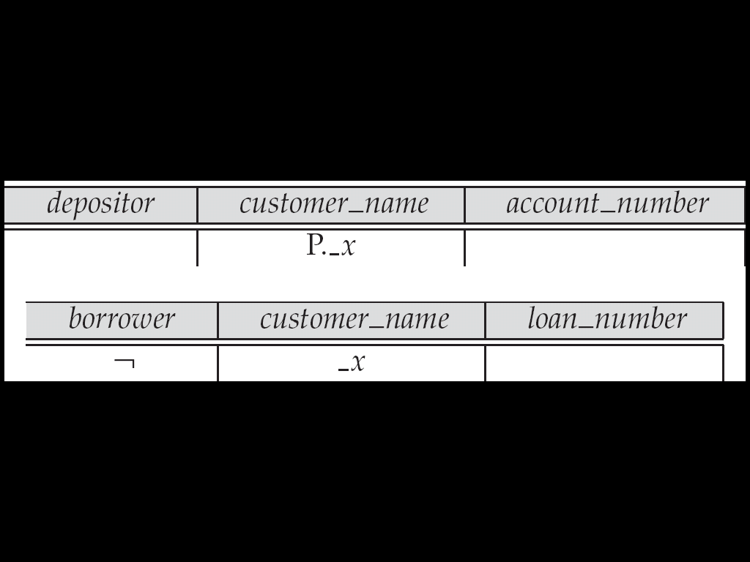
- ¬ means “there does not exist”
The Condition Box
- Allows the expression of constraints on domain variables that are either inconvenient or impossible to express within the skeleton tables.
- Complex conditions can be used in condition boxes
- Example: Find the loan numbers of all loans made to Smith, to Jones, or to both jointly
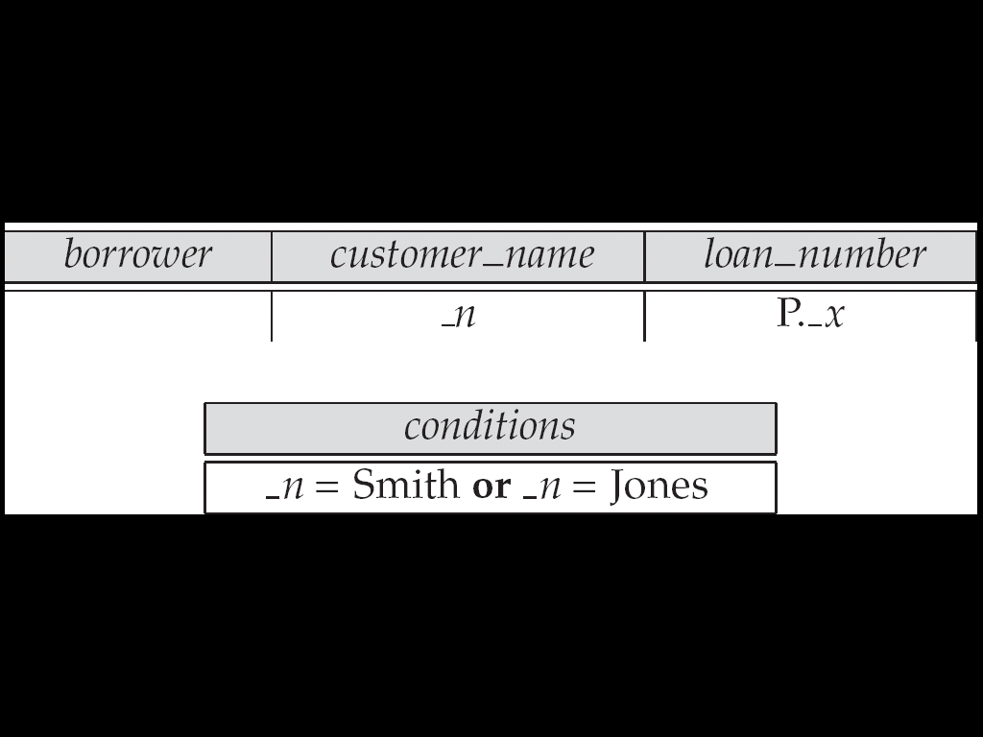
Aggregate Operations
- The aggregate operators are AVG, MAX, MIN, SUM, and CNT
- The above operators must be postfixed with “ALL” (e.g., SUM.ALL. or AVG.ALL._x) to ensure that duplicates are not eliminated.
- Example: Find the total balance of all the accounts maintained at the Perryridge branch.
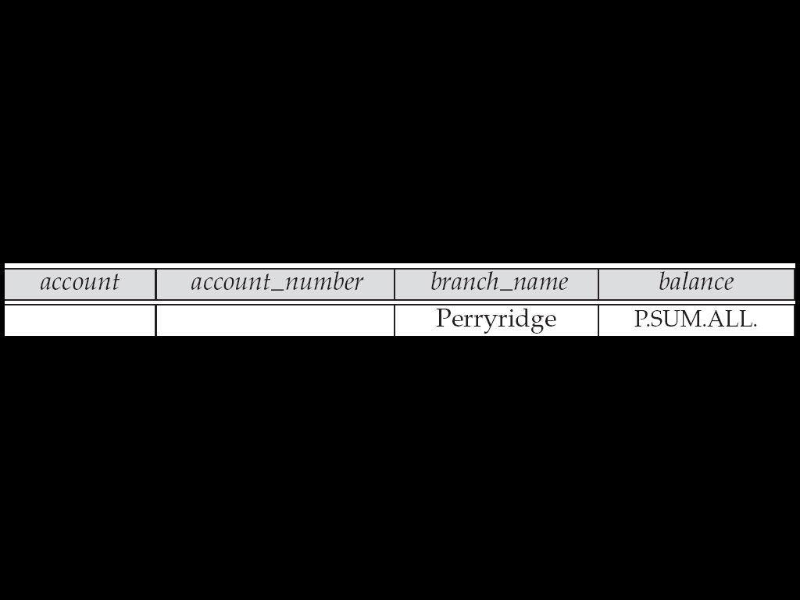
Modification of the Database
- Deletion of tuples from a relation is expressed by use of a D. command. In the case where we delete information in only some of the columns, null values, specified by –, are inserted.
- Delete customer Smith
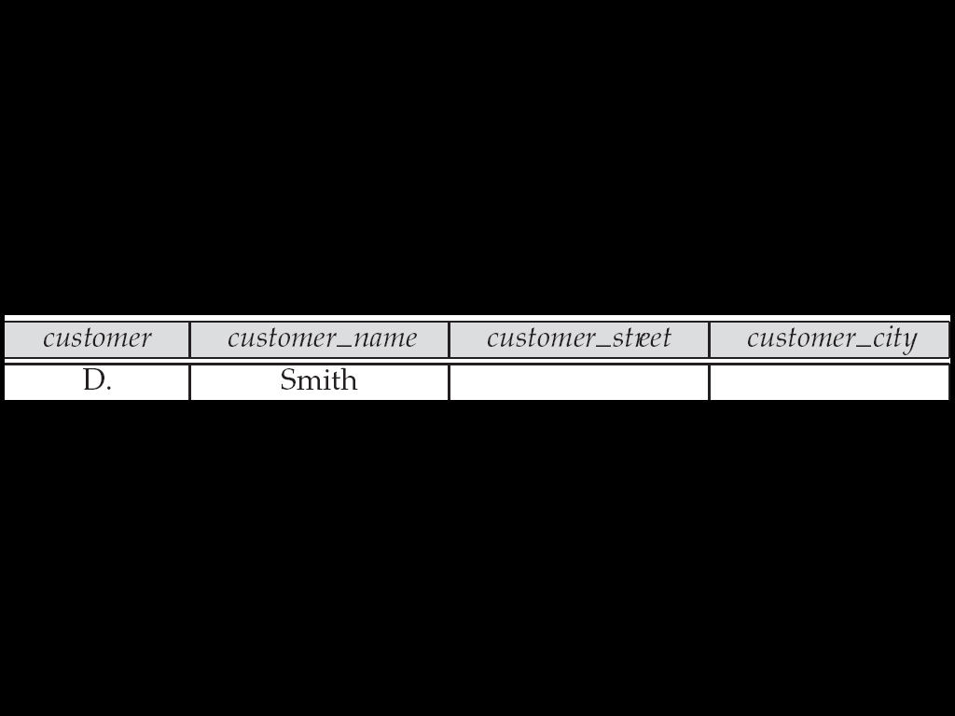
- Insertion is done by placing the I. operator in the query expression.
- Insert the fact that account A-9732 at the Perryridge branch has a balance of $700.
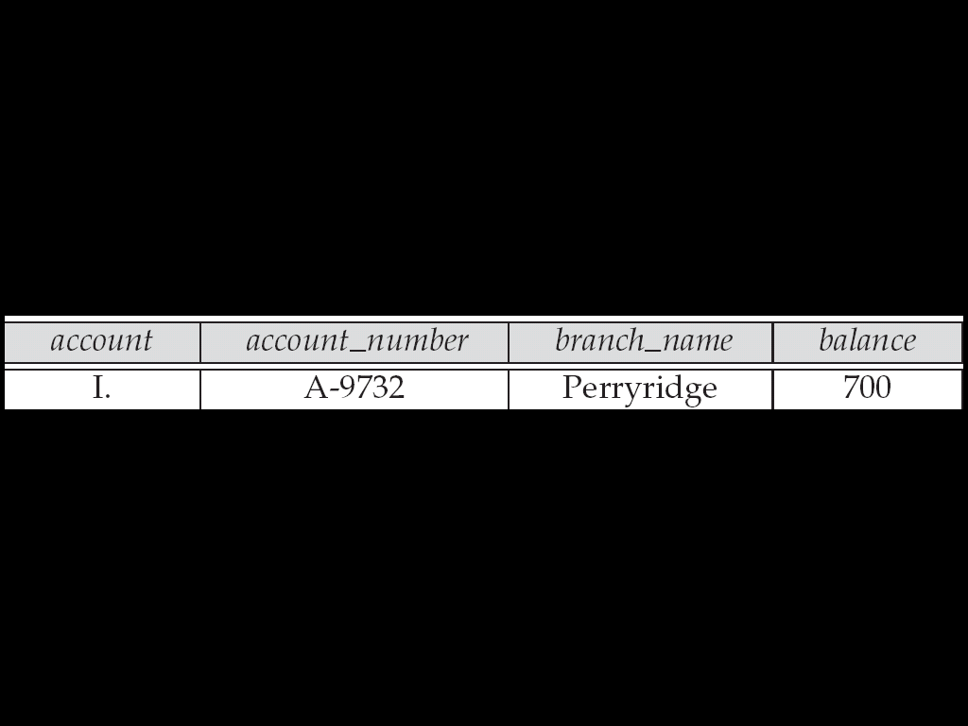
- Use the U. operator to change a value in a tuple without changing all values in the tuple. QBE does not allow users to update the primary key fields.
- Update the asset value of the Perryridge branch to $10,000,000.
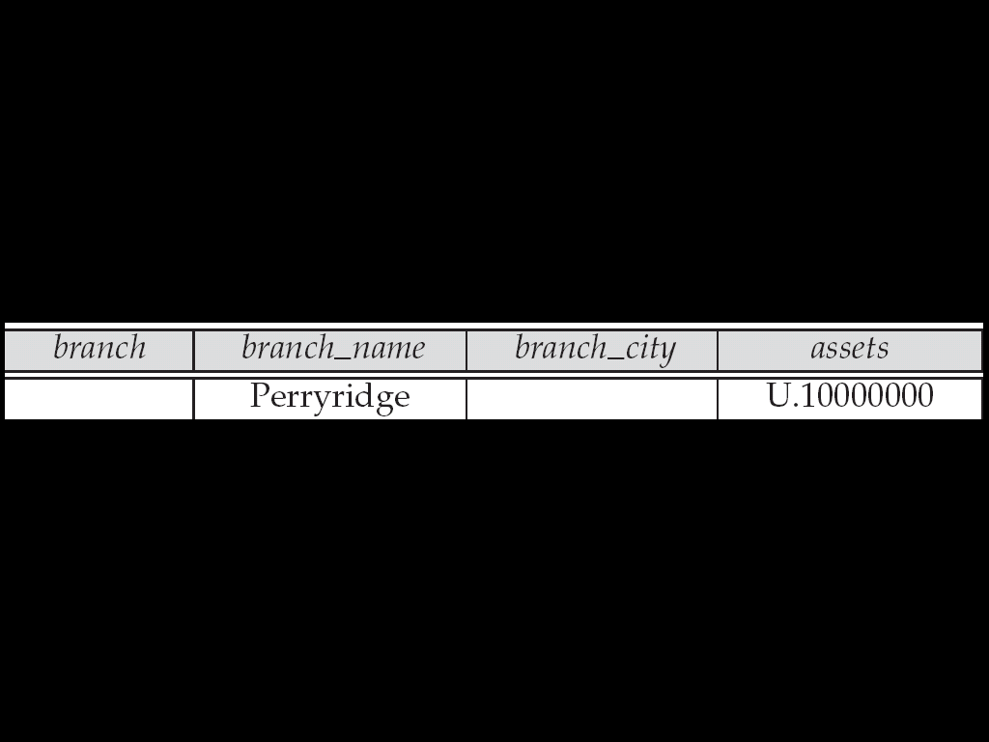
- Increase all balances by 5 percent.
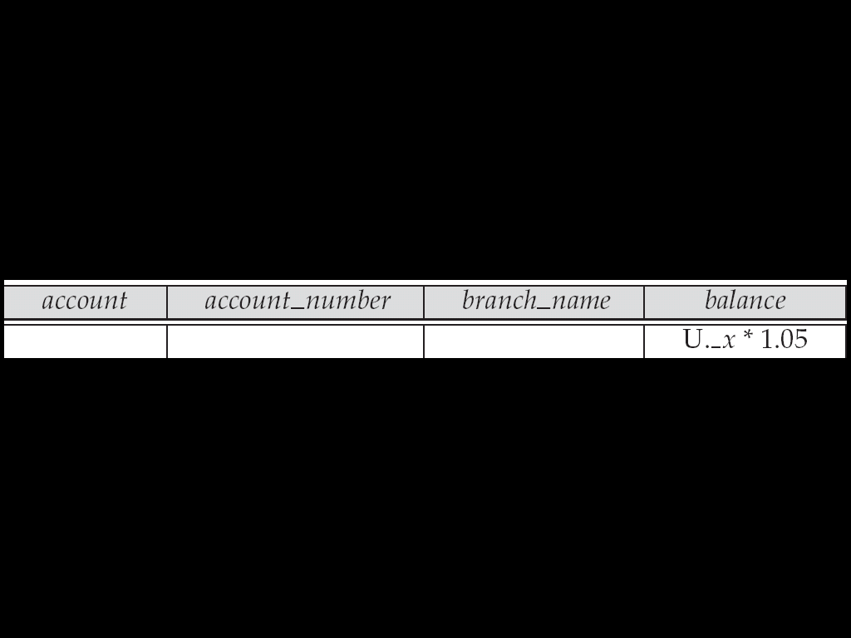
6. List five fundamental operation of relational algebra or procedural query language (NOV 2015)
Relation Algebra
The relational algebra is a procedural query language. It consists of a set of operations that take one or two relations as input and produce a new relation as their result. very useful for representing execution plans.
The operations can be divided into,
- Basic operations:
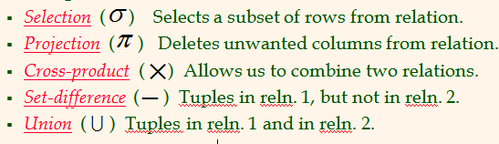
- Additional operations: Set intersections, natural join, division and assignment.
- Extended operations: Aggregate operations and outer join
The fundamental operations:
- Select
- Project
- Union
- Set difference
- Cartesian product and
- Rename.

Selection Operation
For an example
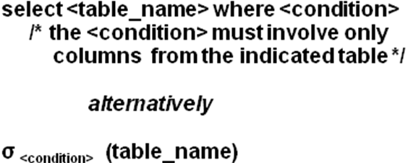
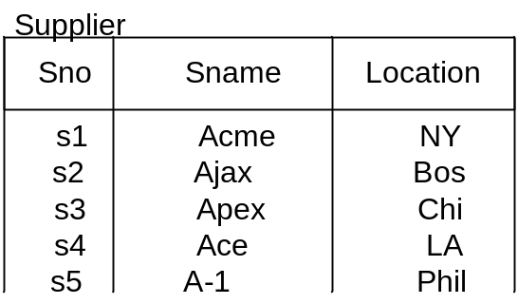
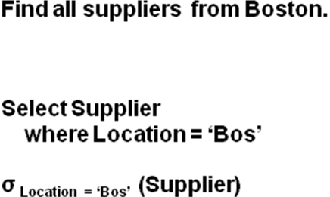
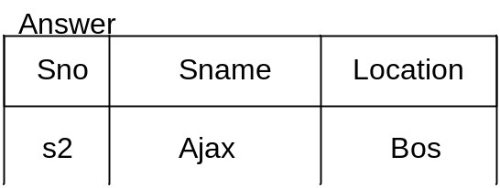

Project Operation
- Projection returns a subset of the columns of a single table.
- It selects attributes from the relation.
- Symbol for project

Syntax
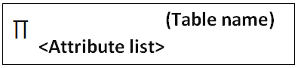
Example
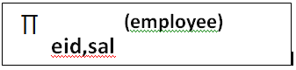

- Combining Select & Project Operation
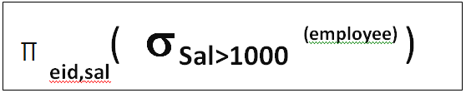
- Selects tuples where sal>1000 & from them only eid and salary attributes are selected.

Example:

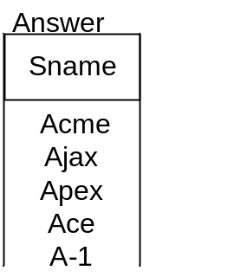
- Query: π _{Sname} (Supplier)

Union Operation
Consider a query to find the names of all bank customers who have either an account or a loan or both. Note that the customer relation does not contain the information, since a customer does not need to have either an account or a loan at the bank.
- We know how to find the names of all customers with a loan in the bank:
Π customer-name (borrower)
- We also know how to find the names of all customers with an account in the bank:
Π customer-name (depositor)
The binary operation union, denoted, as in set theory, by U. So the expression needed is
Π customer-name (borrower) U Π customer-name (depositor)
Therefore, for a union operation r U s to be valid, we require that two conditions hold:
1. The relations r and s must be of the same arity. That is, they must have the same number of attributes.
2. The domains of the i th attribute of r and the i th attribute of s must be the same, for all i.

The Set Difference Operation:
- The set-difference operation, denoted by −, allows us to find tuples that are in one relation but are not in another.
- The expression(r − s) produces a relation containing those tuples in r but not in s.
- We can find all customers of the bank who have an account but not a loan by writing
Π customer-name (depositor) – Π customer-name (borrower)

The Cartesian-Product Operation
- The Cartesian-product operation, denoted by a cross (×), allows us to combine information from any two relations.
- We write the Cartesian product of relations r1 and r2 as (r1 × r2).
- Suppose that we want to find the names of all customers who have a loan at the Perryridge branch. We need the information in both the loan relation and the borrower relation to do so.
- If we write
σ branch-name =“Perryridge” (borrower × loan)
However, the customer-name column may contain customers
- Finally, since we want only customer-name, we do a projection
Π customer-name (σ borrower .loan-number =loan.loan-number (σ branch-name =“Perryridge” (borrower × loan)))

The Rename Operation:
- Unlike relations in the database, the results of relational-algebra expressions do not have a name that we can use to refer to them.
- It is useful to be able to give them names; the rename operator, denoted by the lowercase Greek letter rho (ρ).
Consider the query:
Find the names of all customers who live on the same street and in the same city as Smith.” We can obtain Smith’s street and city by writing
Π customer-street, customer-city (σ customer-name = “Smith” (customer))
However, in order to find other customers with this street and city, we must reference the customer relation a second time. In the following query, we use the rename operation on the preceding expression to give its result the name smith-addr, and to rename its attributes to street and city, instead of customer-street and customer-city:

Π customer.customer-name(σ customer.customer-street=smith-addr.street ∧
Customer.customer-city=smith-addr.city(customer × ρ smith-addr (street, city)
(Π customer-street, customer-city (σ customer-name = “Smith” (customer)))))

Additional Operations:
The fundamental operations of the relational algebra are sufficient to express any relational-algebra query.
However, if we restrict ourselves to just the fundamental operations, certain common queries are lengthy to express.
We define additional operations that do not add any power to the algebra, but simplify common queries.
The various additional operations are:
- The Set-Intersection Operation
- The Natural-Join Operation
- The Division Operation
- The Assignment Operation

The Set-Intersection Operation
- The first additional-relational algebra operation that we shall define is set intersection (∩).
- Suppose that we wish to find all customers who have both a loan and an account. Using set intersection, we can write:
Π customer-name (borrower) ∩ Π customer-name (depositor)

The Natural-Join Operation
- It is often desirable to simplify certain queries that require a Cartesian product.
- Usually, a query that involves a Cartesian product includes a selection operation on the result of the Cartesian product.
Consider the query “Find the names of all customers who have a loan at the bank, along with the loan number and the loan amount”
Π customer-name, loan. loan-number, amount (σ borrower .loan-number =loan.loan-number (borrower× loan))
The natural join is a binary operation that allows us to combine certain selections and Cartesian product into one operation.

The Division Operation:
The division operation, denoted by ÷, is suited to queries that include the phrase” for all.”
Suppose that we wish to find all customers who have an account at all the branches located in Brooklyn.

Step 1:
We can obtain all branches in Brooklyn by the expression
r1 = Π branch-name (σ branch-city =“Brooklyn” (branch))

Step 2:
We can find all (customer-name, branch-name) pairs for which the customer has an account at a branch by writing
r2 = Π customer-name, branch-name (depositor x account)

Step 3:
Now, we need to find a customer who appears in r2 with every branch name in r1.operation that provides exactly those customers is divide operation. We formulate the query by writing
Π customer-name, branch-name (depositor x account)
÷ Π branch-name (σ branch-city =“Brooklyn” (branch))

The Assignment Operation:
- It is convenient at times to write a relational-algebra expression by assigning parts of it to temporary relation variables.
- The assignment operation, denoted by ←, works like assignment in a programming language.
To illustrate this operation, consider the definition of division
temp1 ← ΠR−S (r)
temp2 ← ΠR−S ((temp1 × s) − ΠR−S,S(r))
Result = temp1 − temp2
The evaluation of an assignment does not result in any relation being displayed to the user. Rather, the result of the expression to the right of the ← is assigned to the relation variable on the left of the←. This relation variable may be used in subsequent expressions.
- Explain about DDL and DML (APR 2016)

Data definition
The second group of keywords is the Data Definition Language (DDL). DDL allows the user to define new tables and associated elements. Most commercial SQL databases have proprietary extensions in their DDL, which allow control over nonstandard features of the database system.
The most basic items of DDL are the CREATE and DROP commands.
- CREATE causes an object (a table, for example) to be created within the database.
- DROP causes an existing object within the database to be deleted, usually irretrievably.
Some database systems also have an ALTER command, which permits the user to modify an existing object in various ways -- for example, adding a column to an existing table.
Example:
CREATE TABLE my_table ( my_field1 INT,my_field2 VARCHAR (50),my_field3 DATE NOT NULL, PRIMARY KEY (my_field1, my_field2) )
All DDL statements are auto commit so while droping a table need to have close look at its future needs.

DDL Statements

Create table

Alter table

Drop table

CREATE Statement
Syntax:
Syntax:
Create table <table_name> (column_name datatype (size) constrains);
Eg:
CREATE TABLE em(empno NUMBER,empname VARCHAR2(15),DOB DATE,salary NUMBER,designation VARCHAR2(10));
Table created.
  - Alter Table
The ALTER TABLE statement is used to add, delete, or modify columns in an existing table
  - To Add a column
Syntax:
alter table <table_name> add (column_name datatype (size));

Eg:
ALTER TABLE emp ADD department VARCHAR2(15);
  - To delete a column in a table
Syntax:
alter table <table_name> drop(column_name);

Eg:
ALTER TABLE emp DROP (department);
  - To change the data type of a column in a table
Syntax:
alter table < table_name> modify(column_name datatype(size));

Eg:
ALTER TABLE emp MODIFY department VARCHAR2(30);
  - Drop Table
Used to delete the table permanently from the storage
Syntax:
DROP TABLE table_name;
Eg:
DROP TABLE emp1;

Data Manipulation Language (DML)
A data manipulation language (DML) is a family of computer languages including commands permitting users to manipulate data in a database. This manipulation involves inserting data into database tables, retrieving existing data, deleting data from existing tables and modifying existing data. DML is mostly incorporated in SQL databases. The query and update commands form the DML part of SQL:
- SELECT - extracts data from a table
- UPDATE - updates data in a table
- DELETE - deletes data from a table
- INSERT INTO - inserts new data into a table
Syntax:
- INSERT into table-name values (data1,data2,..)
- UPDATE table-name set column-name = value where condition;
- DELETE from table-name;
- SELECT * from table;
- SELECT column-name1, column-name2, column-name3, column-nameN from table-name;
The most important DDL statements in SQL are:
- CREATE TABLE - creates a new table
- ALTER TABLE - modifies a table
- DROP TABLE - deletes a table
- CREATE INDEX - creates an index (search key)
- DROP INDEX - deletes an index
An example of a table called "TeamIndia":
PlayerId | PlayerName | Address | TotCentury
1 | Sachin | Mumbai | 45
2 | Dravid | Bangalore | 25
3 | Yuvaraj | Punjab | 10

The table above contains three records (one for each person) and four columns

- Explain about nested queries?

In nested queries, a query is written inside a query. The result of inner query is used in execution of outer query. We will use STUDENT, COURSE, STUDENT_COURSE tables for understanding nested queries.

STUDENT
S_ID | S_NAME | S_ADDRESS | S_PHONE | S_AGE
S1 | RAM | DELHI | 9455123451 | 18
S2 | RAMESH | GURGAON | 9652431543 | 18
S3 | SUJIT | ROHTAK | 9156253131 | 20
S4 | SURESH | DELHI | 9156768971 | 18

COURSE
C_ID | C_NAME
C1 | DSA
C2 | Programming
C3 | DBMS

STUDENT_COURSE
S_ID | C_ID
S1 | C1
S1 | C3
S2 | C1
S3 | C2
S4 | C2
S4 | C3

There are mainly two types of nested queries:
- Independent Nested Queries: In independent nested queries, query execution starts from innermost query to outermost queries. The execution of inner query is independent of outer query, but the result of inner query is used in execution of outer query. Various operators like IN, NOT IN, ANY, ALL etc are used in writing independent nested queries.

IN: If we want to find out S_ID who are enrolled in C_NAME ‘DSA’ or ‘DBMS’, we can write it with the help of independent nested query and IN operator. From COURSE table, we can find out C_ID for C_NAME‘DSA’ or DBMS’ and we can use these C_IDs for finding S_IDs from STUDENT_COURSE TABLE.

STEP 1: Finding C_ID for C_NAME =’DSA’ or ‘DBMS’
Select C_ID from COURSE where C_NAME = ‘DSA’ or C_NAME = ‘DBMS’

STEP 2: Using C_ID of step 1 for finding S_ID
Select S_ID from STUDENT_COURSE where C_ID IN
(SELECT C_ID from COURSE where C_NAME = ‘DSA’ or C_NAME=’DBMS’);

The inner query will return a set with members C1 and C3 and outer query will return those S_IDs for which C_ID is equal to any member of set (C1 and C3 in this case). So, it will return S1, S2 and S4.

Note: If we want to find out names of STUDENTs who have either enrolled in ‘DSA’ or ‘DBMS’, it can be done as:
Select S_NAME from STUDENT where S_ID IN
(Select S_ID from STUDENT_COURSE where C_ID IN
(SELECT C_ID from COURSE where C_NAME=’DSA’ or C_NAME=’DBMS’));

NOT IN: If we want to find out S_IDs of STUDENTs who have neither enrolled in ‘DSA’ nor in ‘DBMS’, it can be done as:

Select S_ID from STUDENT where S_ID NOT IN
(Select S_ID from STUDENT_COURSE where C_ID IN
(SELECT C_ID from COURSE where C_NAME=’DSA’ or C_NAME=’DBMS’));

The innermost query will return a set with members C1 and C3. Second inner query will return those S_IDs for which C_ID is equal to any member of set (C1 and C3 in this case) which are S1, S2 and S4. The outermost query will return those S_IDs where S_ID is not a member of set (S1, S2 and S4). So it will return S3.

- Co-related Nested Queries: In co-related nested queries, the output of inner query depends on the row which is being currently executed in outer query. e.g.; If we want to find out S_NAME of STUDENTs who are enrolled in C_ID ‘C1’, it can be done with the help of co-related nested query as:
Select S_NAME from STUDENT S where EXISTS
( select * from STUDENT_COURSE SC where S.S_ID=SC.S_ID and SC.C_ID=’C1’);

For each row of STUDENT S, it will find the rows from STUDENT_COURSE where S.S_ID = SC.S_ID and SC.C_ID=’C1’. If for a S_ID from STUDENT S, atleast a row exists in STUDENT_COURSE SC with C_ID=’C1’, then inner query will return true and corresponding S_ID will be returned as output.

- How to validate the duplicate records?
To validate the duplicate record in the ’user’ relation using the ‘email’ attribute.

SELECT name, COUNT(email)
FROM users
GROUP BY email
HAVING ( COUNT(email) > 1 )

ID NAME EMAIL
1 John asd@asd.com
2 Sam asd@asd.com
3 Tom asd@asd.com
4 Bob bob@asd.com
5 Tom asd@asd.com

This query will give us John, Sam, Tom, Tom because they all have the same email. However, what I want is to get duplicates with the same email and name. That is, I want to get "Tom", "Tom".
The reason we need this: we made a mistake, and allowed to insert duplicate name and email values. Now we need to remove/change the duplicates, so we need to find them first.
- Explain about SQL – STRUCTURED QUERY LANGUAGE (DEC 2014)
Three Types
DDL
DML
DCL
DATA DEFINITION LANGUAGE (DDL)
Data Definition Language (DDL) is a standard for commands that define the different structures in a database. DDL statements create, modify, and remove database objects such as tables, indexes, and users. (Define the Data structure (Or) schema)

DDL Statements

Create table

Alter table

Drop table

CREATE Statement

The CREATE TABLE statement is used to create a table

Create table table_name
(
column_name1 data_type [constraints],
column_name1 data_type [constraints],
column_name1 data_type [constraints],
……..
);
Alter Table

The ALTER TABLE statement is used to add, delete, or modify columns in an existing table

  - To Add a column

ALTER TABLE table_name ADD column_name datatype

  - To delete a column in a table

ALTER TABLE table_name DROP COLUMN column_name

  - To change the data type of a column in a table

ALTER TABLE table_name ALTER COLUMN column_name datatype

Drop Table

Used to delete the table permanently from the storage

DROP TABLE table_name
DATA MANIPULATION LANGUAGE (DML)
A data manipulation language (DML) is a family of computer languages including commands permitting users to manipulate data in a database. This manipulation involves inserting data into database tables, retrieving existing data, deleting data from existing tables and modifying existing data. DML is mostly incorporated in SQL databases. The query and update commands form the DML part of SQL:
- SELECT - extracts data from a table
- UPDATE - updates data in a table
- DELETE - deletes data from a table
- INSERT INTO - inserts new data into a table
Syntax:
INSERT into table-name values(data1,data2,..)
UPDATE table-name set column-name = value where condition;
DELETE from table-name;
SELECT * from table;
SELECT column-name1, column-name2, column-name3, column-nameN from table-name;
The most important DDL statements in SQL are:
- CREATE TABLE - creates a new table
- ALTER TABLE - modifies a table
- DROP TABLE - deletes a table
- CREATE INDEX - creates an index (search key)
- DROP INDEX - deletes an index
An example of a table called "TeamIndia":
PlayerId | PlayerName | Address | TotCentury
1 | Sachin | Mumbai | 45
2 | Dravid | Bangalore | 25
3 | Yuvaraj | Punjab | 10

The table above contains three records (one for each person) and four columns
DATA CONTROL LANGUAGE
The Data Control Language (DCL) component of the SQL language is used to create privileges to allow users access to, and manipulation of, the database. There are two main commands:
GRANT- to grant a privilege to a user
REVOKE -to revoke (remove) a privilege from a user
GRANT command
In order to do anything within an Oracle database you must be given the appropriate privileges. Oracle operates a closed system in that you cannot perform any action at all unless you have been authorized to do so. This includes logging onto the database, creating tables, views, indexes and synonyms, manipulating data (ie select, insert, update and delete) in tables created by other users, etc.
The SQL command to grant a privilege on a table is:
GRANT SELECT, INSERT, UPDATE, DELETE ON tablename TO username;
There are many more forms of the GRANT command, but this is sufficient for this Unit.
Any combination of the above privileges is allowed. You can issue this command on any tables that you have created. For example:
GRANT SELECT ON employee TO hn23;
GRANT SELECT, UPDATE, DELETE ON employee TO hn44;

REVOKE command
The SQL command to revoke a privilege on a table is:
REVOKE SELECT, INSERT, UPDATE, DELETE ON tablename FROM username;
For example:
REVOKE SELECT ON employee FROM hn23;
REVOKE SELECT, UPDATE, DELETE FROM hn44;

